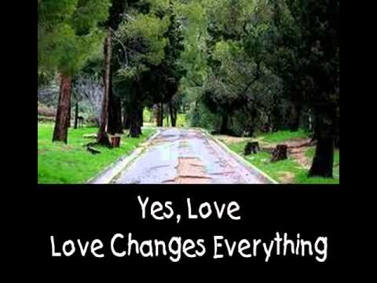
When was the last time that climbed a tree to get a good look at someone? Although a tree does grow in Brooklyn as the novelist Betty Smith named her novel, I have never been much of a tree climber. However, the Gospel of Zacchaeus climbing a tree to see Jesus does bring to mind a memory. About fifteen years ago or, Pope Benedict the VI made a pastoral visit to New York City. The Pope celebrated a Mass at St. Patrick’s Cathedral and I was able to attend. When he appeared at the back of the Cathedral there was great excitement as he the Mass was about to begin. The organ was playing majestic music and the full congregation stood and applauded him. I had a side aisle seat and could barely see the Pope as he processed down the middle age to begin the celebration of the Mass. I noticed an elderly nun standing on a pew so she could get a better view. My mind immediately became judgmental: that is really a bit much and not very reverent. How disrespectful I thought in my pharisaical judgment. When the Mass ended, he processed down the middle up, and to my surprise, down the side aisle where I was sitting. At one point, he was about ten feet away from me. So, I climbed up on the pew to get a better view. After Mass ended, I got about ten texts from my family and friends. Apparently, the camera had been right on me and my friends wondered why I was standing on a pew in St. Patrick’s. God has a great sense of humor.
What brought Zacchaeus to the tree that day when he met Jesus? We do not know for sure. Perhaps, he was bored; there was nothing on cable television that day. Maybe he was curious. If we hear a famous person is nearby, it is hard to resist stopping to get a look. My own best guess is that he was an unhappy sad man without any friends. He was chief tax collector. As you may well know, the Jewish people hated their fellow Jews who collected taxes because they were seen as working for the oppressive government of the Romans. They were also accused of overcharging for their personal gain. They were despised traitors. I suspect he was a bitter man who directed his anger in turn toward those who resented his occupation. He was an empty man with no joy or contentment in his dead spirit.
He is short of stature and no one will let him toward the front of the crowd so he starts to climb a very branchy tree called a sycamore. He wants to get a look at this man who has drawn such a crowd. Suddenly, a voice shouts out, "Zacchaeus, come down quickly, for today I must stay at your house." And he came down quickly and received him with joy. It had been a long, long time since anyone had wanted to dine with him, and this man Jesus, followed by so many, knows him by name and wants to dine with me. This brief sentence transforms this bitter, lonely man to a person of great joy. The crowd grows angry at the saving words of Jesus. Zacchaeus hears their harsh words: When they all saw this, they began to grumble, saying, "He has gone to stay at the house of a sinner." Amazingly, the welcoming words of Jesus has transformed the corrupt tax collector, as he boldly declares: "Behold, half of my possessions, Lord, I shall give to the poor, and if I have extorted anything from anyone I shall repay it four times over." Notice that he now calls Jesus Lord. His vision has changed. The man who spoke to him is no ordinary teacher of the law or common preacher: He is Lord.
When you encounter the living God, when you hear his voice spoken to you, you are changed forever. It moves you to generosity and kindness. A parent of a newborn or a newly adopted child knows this. Love changes you. A teen in the thralls of a first love sees the world in a whole new way. A lifetime of a shared love in a marriage or friendship changes you forever. You find yourself wanting to give more to the other, to all you can to show your love, as your heart and spirit has been captured.
God is the source of love. What would get you or me to climb up that tree to meet him? I know what climbing that tree would do to me. I would meet Jesus
Prayer would be less a chore and more a delight; I would let go of pettiness and resentments. I would be more at peace and have more joy. I would appreciate others and myself as a gift. I would forgive those who hurt me. Climbing tree can be risky. I could fall and or laughed It is safer to stand on the solid ground. There is not a moment or an hour when Jesus is not saying, Today, I want to dine with you. Come and be with me.
I thought of the words of the song Love Changes Everything as I thought about how our relationship with Jesus calls us to let him transform us:
Love, love changes everything
Hands and faces, earth and sky
Love, love changes everything
How you live and how you die
Love will turn your world around
And that world will last forever
Nothing in the world will ever be the same
Love will never never let you be the same
Love will never never let you be the same

