For many people, although there is stress and times of near exhaustion, Christmas is their most favorite time of the year. There is the fundamental joy of celebrating the birth of Jesus. The anticipation of little children, the scent of the Christmas tree, the wrapped gifts, the sparkling lights, and the wonderful baked cookies all add a great sense that may lead us to sing along with the Christmas carol Joy to the world.
Yet, I have found that Christmas also has a tinge of sadness. Perhaps, it is the melancholic Irishman in me, but I am more conscious at this time of the year than any other of those loved ones who no longer sit our Christmas table. I think of my Dad who worked for more than forty years at Grand Central Station and every year took us over to the beautiful building to see the trains that he had helped set up. I cannot walk into our kitchen at home in Brooklyn and not see my Mom preparing the Christmas turkey. My late sister Gerry was a Sister of St. Joseph. After celebrating Christmas at her convent, she would rush to our home and come in full of excitement. I always miss them, but especially at Christmas.
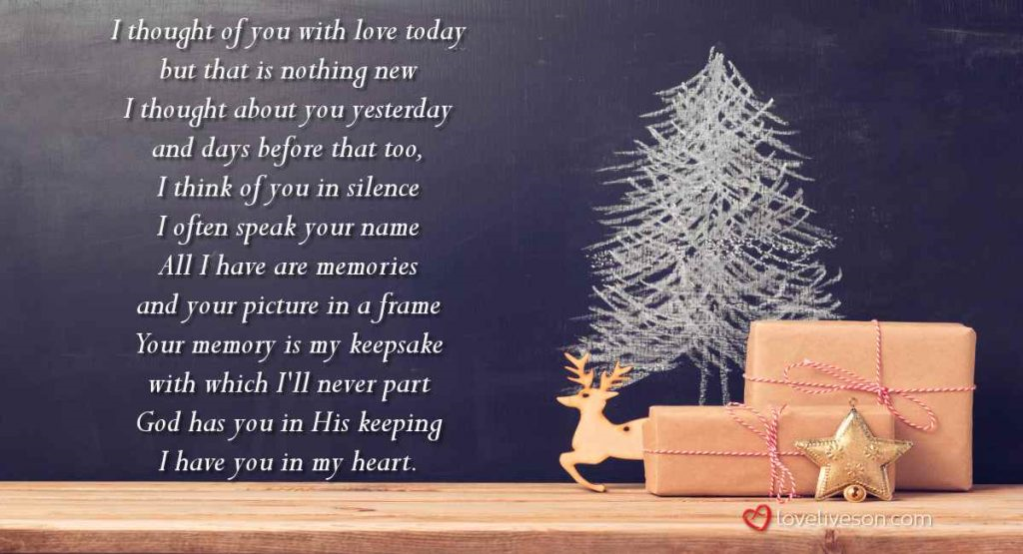
God is good. Since those days of Christmas, our family has grown; I have two nieces and a nephew and their wonderful spouses, and their eight children. We are a growing family and there are many reasons to rejoice this season. As a person of faith, I truly feel the presence of those I love who have gone home to God as we rejoice in the celebration of the birth of Jesus Christ. They are always with us. I love this poem from a book named Seeing Haloes by John Shea:
Spirits at Christmas
Like God,
Bidden or unbidden
Spirits will arrive.
For some reason
They love Christmas
Perhaps it is the prophesies
About the Child.

We know who they are—family, friends
Anyone who ever wandered into the welcome our smile.
No need to set an extra plate at table.
They only hunger now
For a moment of our memory.
But be assured,
Their mission is not to haunt.

They will not enter in the usual way.
Do not listen for the doorbell.
Do not wait for a card.
Do not scan your emails.
Do not check your spam.

They appear from inside,
When our minds are too exhausted
To block entry
And we have given back fighting tears.

Too often we push them away,
Insisting over and over again,
“They are gone. They are gone.”
We hug our loss to our heart.

Missing the point:
They are sent
As a Hallelujah chorus
To sing us out of this narrow box
We mistake for the fullness of life.

