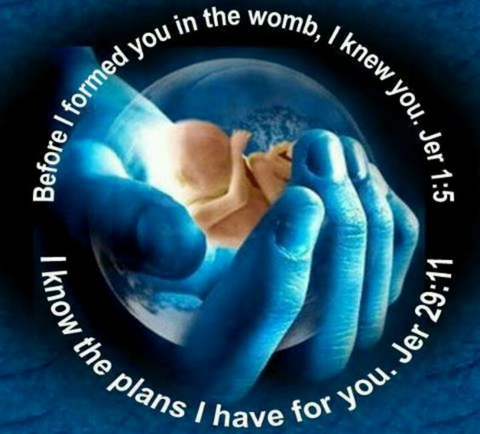
There is a famous quote that is sometimes called a Chinese curse: May you live in interesting times. I decided to do a little google research and found out that although the words are well known, it seems that the Chinese more than likely did not produce these words. As for myself, I wonder whether it is a blessing or a curse to live in interesting times, and secondly, are all times of all ages interesting. Certainly, we are living in interesting times. On the front page of the newspapers we see the President of the United States signing an important trade bill on one side and on the other side the Speaker of the House is signing the articles of impeachment. Certainly, these are interesting times. We live with continual fear of state terrorism and home-grown domestic violence. Over the course of my lifetime, there was the Vietnam War, the resignation of a both a pope and United States President, the election of an African-American President and the fall of the Berlin War, the assassinations of President Kennedy as well as great civil rights leader Dr. Martin Luther King whose holiday we mark this week. We have seen men walk on the moon and experienced terrible scandals in the Catholic Church. Is it a blessing or a curse to live in interesting times?
As I prayed over the readings today, I was captured by a verse from the prophet Isaiah in our first reading: God formed me as his servant from the womb,
that Jacob may be brought back to him and Israel gathered to him; and I am made glorious in the sight of the LORD, and my God is now my strength! This verse brought to mind a similar verse from another great Biblical prophet Jeremiah: Before I formed you in the womb I knew you, before you were born I set you apart; I appointed you as a prophet to the nations." Surprisingly similar, both texts speak about an infant in the womb already being claimed by God for a future mission. From the moment of conception, they were loved by the God who breathed life into each of them, endowed them with a soul that will live forever.
This January 22 will mark the 47th anniversary of Roe v Wade: a decision by the U.S. Supreme Court that declared a pregnant woman is entitled to have an abortion until the end of the first trimester of pregnancy without any interference by the state. As we know, in many states this has evolved to allowing the termination of pregnancy into the ninth month, and even the present Governor of Virginia said: that in certain very rare cases, a living infant, born alive after an abortion, could be allowed to die. I am ashamed of my home state of New York that celebrated the passage of the most unrestricted abortion bill in the United States with a standing ovation by the legislature and the lighting up of the, ironically, the Freedom Tower.
When I listed some of the most dramatic moments of the past decades, I believe that the issue of when does life begins and how to protect human continues to a major fault line in our nation. I believe the fierce debate about Supreme Court Justice Cavanaugh was far less about what he might or might not have done as a teenager and fare more about possible votes on the Supreme Court. At last year’s pro-life march, a group of Catholic high school students were vilified by the media for supposedly verbally abusing an elderly man. CNN has announced that it has settled a lawsuit brought against it for defamation of one of the students.
Whenever I address the issue of life, I do so with some hesitation. I know there may be people who hear me who may have had to make this most difficult decision or had to advise someone else. Sometimes the rhetoric of a few can condemn such people. I do not. I know that God is always merciful and forgiving. No sin is outside his mercy. So, if you bear the scars of having made such a choice, know that you are a child of God.
Secondly, the protection of life in the womb is not only a moral issue. When we reduce this question to a moral issue, it is easy for others to say that is your belief and your welcome to it. I have mine. The core question for me in this debate is always: what are the legal rights of an infant in a womb. When does a living being, very dependent on a mother for life but also clearly a different being, have rights. That is a legal question that I think has been put aside because to ponder it might lead to haunting questions for those who see only a mother’s right and not that of the life she carries.
The final point that I make today is that as Catholics, even though the right to life is so fundamental a right, we must avoid being accused of only being interested in the baby in the womb. Our parish supports Birthright, a wonderful program that seeks to offer a family an alternative to an abortion with emotional and financial support. We must also work for an end to the death penalty, the environmental care of God’s creation, peace in the world, the homeless, food for the hungry, and care of the sick. It is a lie to say Catholics only worry about a single issue. Because we have been gifted with life and the love of God, we are both challenged and called to protect and care for those about to be born, those about to die, and all who have given the precious gift of life by our Creator. Before I formed you in the womb, I knew you.

