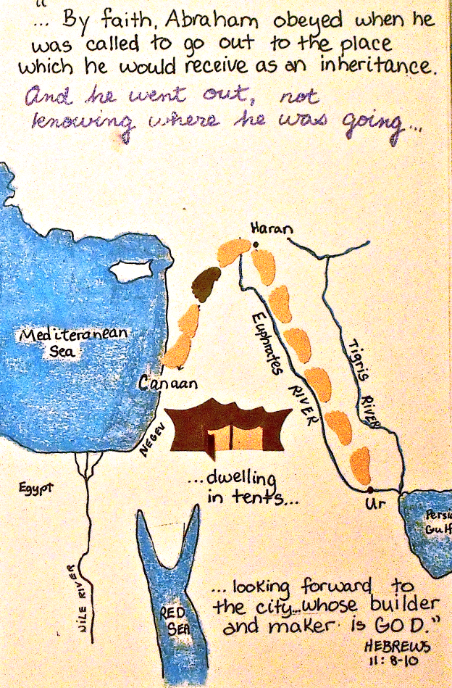
My Mom and Dad grew up in the same areas of County Clare in Ireland, and eventually they immigrated separately to New York. My mother was probably 17 and my Dad in his early twenties. They left all they knew for a new world. I have heard of what was called the American wake; that is when all the family members and friends would gather at the home of the young person leaving to say farewell. My Mom and Dad never saw their parents again. My father only went home to Ireland once for tragic funeral and my mother never visited the land of her birth. The connected again in New York, married, lived in the Bronx for a time, but fortunately escaped the land of the Evil Empire, the New York Yankees, and settled in Brooklyn. Our family continues to live in the same house for the past 75 years. I live stability. Many of your parents, grandparents, and other ancestors made similar journeys from Italy, Poland, Spain, France, Germany, and so many other lands. Today, many immigrants continue to come to America from all over the world. I found leaving home to go the seminary difficult. As a Redemptorist, I have had only five assignments, which is somewhat unusual. Each assignment began with my being nervous, wondering if I could do the ministry, how I would get along with the other Redemptorists, and how I would get over leaving the last assignment which had become comfortable to me. In my experience, some people love change, but I do think many of us like to stay put, not have to start making all new friends, and leaving people we care about. Knowing how many of you have Navy connections, I suppose you are quite familiar with moving from place to place as your serve our nation.
There is a story that I like to tall that goes like this: there was a man who always wanted to go to Disney World. Oh, he dreamed and dreamed of the Magic Kingdom, the electric light parade, and seeing Mickey and Minnie. He finally has saved enough money for the travel, booked his flight and soon found himself on the runway ready to experience his greatest dream. The plane took off and his mind raced with all the fun and adventure he anticipated. After a three hour flight, the captain’s voice came over the loudspeaker, Good afternoon, ladies and gentlemen. Welcome to Topeka, Kansas. The man leaped out of his seat saying I wanted to go to Disney World. I use to tell this story all the time of retreats to engaged couples. I said that is what getting married was like. When you get married, you think you are going to Disney world, but you end up in Topeka, Kansas. Topeka, Kansas is not a bad place. It can be a happy and wonderful place, but is not Disney World. A few weeks I put the traditional wedding exhortation in the bulletin: part of it reads this way: This union, then, is most serious, because it will bind you together for life in a relationship so close and so intimate, that it will profoundly influence your whole future, That future, with its hopes and disappointments, its successes and its failures, its pleasures and its pains, its joys and its sorrows, is hidden from your eyes. You know that these elements are mingled in every life, and are to be expected in your own. And so not knowing what is before you, you take each other for better or for worse, for richer or for poorer, in sickness and in health, until death. The challenge of what the future will bring applies to all of us whether married or not; students going to a new High School or College. Ask Will I be happy” Will I make friends? How will I do in my studies? People who take a new job or position are naturally anxious. The very reality of aging or simply daily living brings us to constant change. Words like the coronavirus, biopsy, Alzheimer’s can be very upsetting. Although we have our routines, every day is an adventure.
This week’s first reading present us with a nomad named Abraham who has a large extended family. He encounters God. This is a key historical moment of the Sacred Scriptures. God is forming a people, a chosen people, whom he will use in a profound way to bring revelation to the world that has fallen more and more distant from God. This invitation from God will lead to the prophets, Moses, King David, and finally to the Son of God Jesus Christ. Like the Virgin Mary who is asked to be the mother of God, Abraham, is invited by God to enter into a profound relationship that will change the course of history and began the process of redemption that will be completed in the death and resurrection of Jesus. Three of the great religions of the world, Christianity, Judaism, and Islam trace back to Abraham their father in faith. Abraham makes a profound act of trust in God at this moment as hears the call to go to a land that he knows not of. It is a leap of faith in God.
Peter, James, and John, who are three apostles who were the first called and who hold a special place with Jesus, are overwhelmed by the sight of the Glory of God shining through Jesus. They get a glimpse of the divinity of Jesus in a most profound way. Peter says to Jesus, let us build tents and stay here forever. Jesus sys, no, we must go back down the mountain and walk the path that we are called to follow. We know this path will lead Jesus to be brutally crucified. Ultimately all three of these apostles will be martyred for their faith. At the core of faith is coming down the mountain and continuing to trust in God and to seek to be faithful to the promises we have made. It is to keep walking in faith on a path that we cannot ever completely know where it will lead us, other than ultimately to the arms of God.

