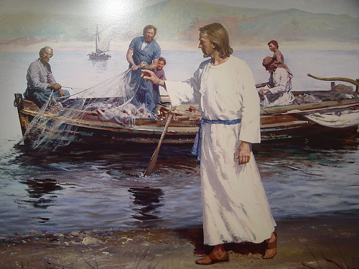
Probably one of the most common sentences spoken in the English language is: somebody should do something about that! It might be a full garbage pail, a leaky sink, a stuffed up toilet, a dirty diaper, a poor Wi-Fi signal, or a list of about ten thousand more possibilities. Other than the dirty diaper, I have found out that such complaints often end up on my desk as pastor. This leads me to say: who can I find who will do something about this.
Sometimes when you watch the news, you hear of some situation where someone will describe a neighbor this way: he is a wonderful neighbor, he keeps to himself and doesn’t bother anyone. Strange that the sign of a good neighbor is that he/she chooses to not get involved in assisting those around him/her. As a confirmed New Yorker, I was programmed when riding the subway to never make eye contact and to keep the most important commandment of all: never get involved.
What would get you involved? What would get you do to something about it? I remember when Mother Teresa of Calcutta died and her funeral was on television. I watched it on ABC television with Peter Jennings as the newscaster; as his commentator was a man named Christopher Hitchens. Hitchens, who has since passed away, was an avowed atheist who had written a scathing book attacking Mother Teresa. This would be equivalent of having the racist David Duke do the commentary for the funereal of Dr. Martin Luther King. I was so outraged, I jumped out my recliner, which is quite a commitment in itself, and sought to find the phone number of ABC News. Finally, finding the number, I made my call. After being on hold for almost thirty minutes, I weakened and gave up.
I can recall before this past Christmas was Annapolis the boat show with the parade beautiful lighted boats. Our rectory and property have a prime few for this event. Unfortunately, I was out of town and arrived just as the show ending. I had had a long day traveling to a funeral and I was tired when I arrived home. To my shock, somebody had taken the pastor’s parking spot! It was a big four wheel truck. I also noticed that there were many cars in our parking lot and was going to act. I saw two young people park and start heading to town. I said , are you going to church. They said no. I said you’re not supposed to park here unless you are going to church. They said they were sorry and I felt guilty and said , ok, you can stay. Then I saw a couple heading to their car. I was going to give them a fierce lecture. I asked, why are you parked here? Their response was Hi Father Pat, we just spent the last hour adoring Jesus in the Adoration Chapel. I was embarrassed and thanked them for their devotion to the Lord. So, I left a note on the truck in my parking spot that said, I am going to report you to the authorities which were not a lie since I was the authority.
I thought of these moments as I prayed on our Gospel for today. Four fellows are out working as fishermen. They have probably been at the same job for many years. Just another day on the Sea of Galilee. A man approaches with an invitation. Come, follow me. What was it about this man that so penetrated Peter Andrew, James and John? What could make them act so impulsively and start to listen to this man? Soon, they leave their boat and their old lives to begin the greatest adventure they would ever experience. They would follow him for three years. They would grow to love him to the core of their beings. They would see him challenge the smug complacency of the religious leaders. They marvel as he healed the sick and feed the hungry. They would drink the wine with him at Cana, hear stories about prodigal sons and good Samaritans. They would have their feet washed by him and dine at a meal called the Last Supper that would consecrate them as priests. They would weep in shame for running away on the night their beloved friend was arrested by the Romans. These four fishermen would weep upon hearing of his death on a cross and be devastated because all that they had come to hope in had died on a Friday.
Their friend Mary Magdalene would knock on the door of the place where they hide for fear of suffering the same fate as Jesus. She would tell them a strange tale of seeing Jesus alive. They would not believe. It could not be true. Soon, they would come face to face with the Risen Jesus. Then they too would see him and share a meal with him the shores of the very lake, where they had just caught fish. He would commission these men and seven others as the stones upon which he would build his church. They the most ordinary of men: fishermen, tax collectors, working men. He would tell them that they through the power of the Holy Spirit they are the people on whom he would commission to preach the Good News..
All of this happened because they left their boat on sunny morning. They decided to follow him. Today, you left home, perhaps a warm bed, a rushed breakfast, perhaps with a mind filled of so many things that must be done today. Yet, you and I are here. Jesus is here. He today, and every day, invited us not just to settle and say let somebody else do something about it. He calls you and me with a great invitation to go on the adventurous journey with him to love one another.
Now, a testimony to God’s great sense of humor. I had just finished preparing this homily and sat back in a moment of satisfaction. It was about 8:00 p.m. in the evening and staff had gone home. I heard a gentle knocking on a the locked door outside my office that leads to the rectory. I said it must the wind. The knocking persisted and I got up and went to the locked door and there I met a young man who told me, Father, your rectory bathroom is leaking and someone better do something about it. You can’t make up!

