Then they asked him,
"Teacher, when will this happen?
And what sign will there be when all these things are about to happen?"
He answered,
"See that you not be deceived,
for many will come in my name, saying,
'I am he,' and 'The time has come.'
Do not follow them!
When you hear of wars and insurrections,
do not be terrified; for such things must happen first,
but it will not immediately be the end."
Then he said to them,
"Nation will rise against nation, and kingdom against kingdom.
There will be powerful earthquakes, famines, and plagues
from place to place;
and awesome sights and mighty signs will come from the sky

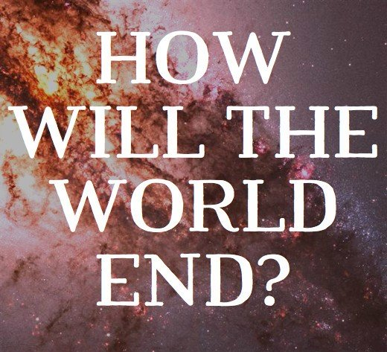
Most of us our pet personal phrases that tend to become clichés. I often find myself saying, relax, it’s not the end of the world. I suppose the closest, as least as far as I know that the world came to experiencing the end of the world, was in 1962. Those of you who are a little older, if you are willing to admit to that, may recall living through the thirteen days of the Cuban Missile Crisis. The crisis took place during October of 1962. The Soviet Union had secretly placed nuclear weapons in the Cuba that could hit New York and Washington in about five minutes. The missiles were not yet activated but the Russian technicians were working day and night to get them in place and ready. The United States Government became aware of this and demanded that the Soviet Union move them out of Cuba and back to Russia or our government would take immediate action to attack Cuba and take down these great threats to our nation. John Kennedy was our president. From my own study and reading I believe that this is the closest moment in history to the complete destruction of the world as we know. It was an incredibly tense 13 days. A movie called Thirteen Days in October captures rather well these events; one scene shows long lines around Catholic churches as people seek to go to confession. As a twelve year, I filled the large sink in our basement with water so we would have drinking water if the bombs fell. Thanks are to God, the two world leaders were able to arrive at a resolution and the warheads were removed and there was universal sense of relief.
I suppose September 11th, 2001, brought those of us who lived through that day with a similar sense that the world as we knew it was changing and we had no idea what was happening. Today’s scriptures capture what the early Christians were experiencing in the first century, after our Lord Jesus returned to the Father. Jesus warned his followers: When you hear of wars and insurrections, do not be terrified; for such things must happen first, but it will not immediately be the end." Then he said to them," Nation will rise against nation, and kingdom against kingdom. There will be powerful earthquakes, famines, and plagues. The majority of the first Christians were Jewish and they saw the temple destroyed by the Romans. It is hard for us to grasp what this experience was like for the Jewish people. You might recall watching news accounts of the people of Paris weeping and praying as Notre Dame Cathedral was burning. The temple in Jerusalem was the heart of Jewish life. It was there that they offered sacrifice and made annual pilgrimages. It was beyond their imagination to see it destroyed. Additionally, at the time this scripture was written under the inspiration of the Holy Spirit, those who believe in Christ were being hunted down and killed.
I wonder how we would characterize our present age. We seem to be a in a time when war and threats of war are continual. We know how very real both acts of terrorism and random mass shootings are. We have serious worries about the impact we have on both the environment and climate. We as a nation seem to be deeply divided in our politics and beliefs. We are suffering through serious scandals in our faith and a significant decline, especially among the young, in the practice of the Catholic faith. Secularism and atheism is on the rise, and there is the reality of what is called the culture wars. Certainly, family life has always had its challenges but my sense is it there are often more breakdowns and struggles today than in the past. Even though we live in a great age of technology and communication, people often speak of being isolated and lonely. In spite of the wonders of our medical care, disease and death are never far from our lives.
I suppose every generation could raise such a haunting list of worries and concerns. Are much different than our ancestors in faith whom felt the world was ending. . Can we take hear the words of today’s Gospel: When you hear of wars and insurrections, do not be terrified; for such things must happen first, but it will not immediately be the end." My feeling is not so much the world is ending but the world as I knew it has radically over the course of my life. Life has improved in some ways and gotten worse in other ways. How do I look on the world around me? How do I maintain a sense of peace and contentment in age with seemingly so many dangerous realities? Can I resist living in fear, lacking trust in others, growing cynical, a feeling of us and them, seeking to distract myself with entertainment and personal comfort? The Word of God we heard today is not ancient history. It is today’s news. Let these words in our time of living in a complicated and challenging age be our strength and comfort. Carry them as mantras in your heart:
The prophet Malachi: But for you who fear my name, there will arise; the sun of justice with its healing rays
Jesus said, not a hair on your head will be destroyed. By your perseverance you will secure your lives."
Rejoice: Stand erect and raise your heads because your redemption is at hand. Rejoice

