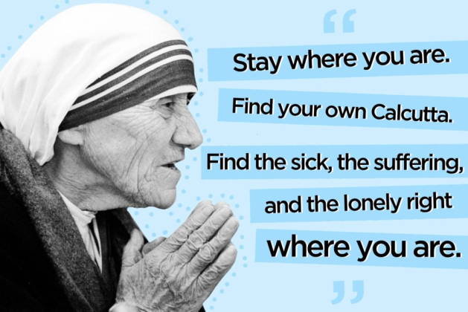
Bless me Father for I have sinned. As I was reading the familiar Gospel of Dives and Lazarus (not the Lazarus we know as the friend of Jesus), a very painful memory came to mind. It was the winter, probably a few days after Christmas three or four years ago. I was home with my family in Brooklyn, and we decided to go over to the city. Funny, when you live in Brooklyn, you are part of the City of New York, but we always refer to Manhattan as the city. We had been able to get some half-price tickets to a Broadway show, saw the Rockefeller Center Christmas Tree, and had dinner at our favorite Irish pub. We took the subway back home and were walking up the street to our family home at about 11:30 pm., and we saw a man lying on the sidewalk. It was clear that he was drunk. We passed him, doing nothing, and came home. The next day, all of us who passed him were filled with shame and guilt as we spoke to one another about what we had seen and felt. I am not sure exactly what we could have done to assist him, but at least we could have called the police and not left him on the cold street. Although none of my family would call ourselves rich, we are certainly comfortable in life and felt like the rich man of the Gospel.
I often found that as Catholics we have a great deal of guilt about sexual failures. That is understandable since it is a serious matter to misuse the gift God has given us. We need to confess such sins and be embraced by the mercy of God. Still our Scriptures speak far more about the need to love our neighbor and to help those in need than they do about sins of the flesh.
In today’s first reading, the prophet Amos speaks powerful words to the community: Lying upon beds of ivory, stretched comfortably on their couches, they eat lambs taken from the flock, and calves from the stall. Yet, I am not sure how often we admit to sins against social justice. When you and I examine our consciences do we look at if we might have sins, either by commission or omission, of racism, prejudice against foreigners, the homeless, sins against the environment? This Gospel is haunting to any of us who have a comfortable life. I think of the words of the great modern prophet of social justice, Dorothy Day, who said religion should comfort the afflicted and afflict the comfortable. This Gospel does afflict me. Dives is not a cruel or bad man. He doesn’t attack or hurt Lazarus or have him evicted from his property. When he finds himself in the afterlife suffering, he is a good enough person not to want to see his brothers suffering the same fate so he asks he can back and tell them to change their lives, but he is not permitted to do so. His great sin is that he does not see Lazarus. He never notices him.
The other day, a parishioner took me on a tour of the Lighthouse Shelter. I was deeply impressed with the work being done there and the fact that there were over 3000 people volunteering there, some of them our parishioners. The food drive last week from our parish brought in 9000 pounds of food. The director of the Lighthouse praised the great generosity of our parish in doing so much for this remarkable effort to help those in need. Our students from our schools also volunteer at the Lighthouse. Parishioners are very generous to our poor boxes. Long before I came to St. Mary’s Parish as your pastor, I was hearing about the remarkable work of the St. Vincent de Paul Society. I know we have the ministry of Birthright in our parish that seeks to help a woman who is pregnant to have the support and necessary assistance to help them be able to have their baby. I was happy to hear that for a week a year we shelter homeless people in Seelos Hall at St. John Neumann Church. Since I have been here, almost every meeting I attend seem to point to the concern of their people in need that we can help. I have only been here a month and I can see this is just a small sample of the caring spirit of St. Mary’s.
There are two ways that I think about helping others in need. One is what I could do to change structures that create social justice issues. What can I do to help being an end to homelessness, hunger, housing and education issues? Perhaps, one or the other person might have such gifts and God bless them and we need to support them in any way we can. We can vote for people who have values that we see in line with our principles. We can donate to such good causes but generally, we cannot do much about such broad and overwhelming issues.
I think of the example of Mother Teresa. She was criticized by a few for not changing the social structures that cause people to be dying on the streets. That was not her calling and mission. She was hands on, person to person, and helped people die knowing they had been loved in their last days. It is difficult for me to think of seeking to change major unjust issues facing the world and the church.
I take great comfort in the words of Jesus who told us that a cup of cold water given in name will not be forgotten. I can do that. I can give cups of cold water. I can help one specific charity, I can assist one needy person in some way, I can be kind a gentle with someone who needs some help. I can notice and see and make an effort not to walk by. When people told Mother Teresa they could not imagine leaving all they had and going to Calcutta to serve those dying on the streets of Calcutta. She responded, No, that is not for everyone. You must find your own Calcutta wherever you are. Do we have a Calcutta in our lives? We begin the journey by first seeing those who are Lazarus to us.

