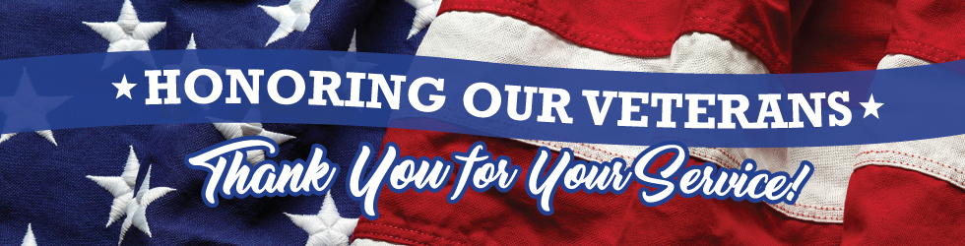
Thank you for your service has entered our national vocabulary as a greeting to both active military men and women and to those who are veterans. I think as a nation we learned from the sad experience of not treating our military personnel with respect during the time of the Vietnam War. Although there may be times when we may disagree with a particular decision of our government in its use of the military, gratefully we have come to know that the men and women who have and continue to serve our nation are patriots who deserve our appreciation. Thankfully, greater efforts are being made to care for our veterans who are ill or aging. More still needs to be done. It is a national tragedy to hear of veterans being homeless and in need of better medical care.
During my eight years in St Martin of Tours in Bethpage, I think I had perhaps ten or so funerals for men who saw action during World War II. Tom Brokow wrote a book called The Greatest Generation about the men and women who rose up and defeated the evils of the Nazi and Japanese war lords. Brokow writes that the WWII generation shares so many common values: duty, honor, country, personal responsibility. Some of them saw terrible realities during the war, did heroic deeds, came home, rarely spoke about what they did and raised their families and help continue to build our nation. I have to say that I have experienced most veterans of all generations, whether they went to war or not as good and humble men who loved their country and did their duty to the best of their ability.

I hold a special place in my heart not only for veterans but for their families. My niece Chrissy married a West Pointer named Tom who was deployed several times to Afghanistan and Iraq. He never told us much of what he did since it was confidential. She and Tom had three children who were young at the time and I came to learn not only the sacrifices that those in uniform make but also their families, struggling with their ordinary family and household details, missing their spouse, and worrying every moment how he or she is doing.

When I see a Midshipman in town or at Mass here, I am struck by just how young they are. I guess that is a sign of my getting older; some of them are still teenagers. I am sure they have many reasons for coming to the Academy, such as maybe family legacy or tradition or for the quality education, but I also know that they love their country and want to serve her. They inspire me with their commitment and dedication.

As Christians who follow the call of Jesus Christ to love one another, we never seek to glorify or rush into war. I think of the quote from President Dwight D. Eisenhower: I hate war as only a saw soldier who has lived it can, only as one who has seen its brutality, its futility, its stupidity. As a people we ask a great deal of those who serve in the military, who prepare for war, may even go to war, and then return to civilian life. We pray our nation only fight war as last resort. We pray our leaders only send our young men and women to war when all other remedies for peace have failed. We seek to do all we can to protect the innocent during the war. One of the greatest minds the Catholic Church has ever produced is St. Thomas Aquinas; He wrote: “In order for a war to be just, three things are necessary: First, the authority of the sovereign, secondly, a just cause thirdly, a rightful intention.” How difficult it is for any individual or even nation to reach that truth. We pray for a time when the words of God given to us through the prophet Isaiah, who will soon hear during the Advent season, will take hold in the hearts of the human race: He shall judge between the nations, and shall decide disputes for many peoples; and they shall beat their swords into plowshares, and their spears into pruning hooks; nation shall not lift up sword against nation, neither shall they learn war anymore.

My favorite patriotic song is The Battle Hymn of the Republic, in particular the last stanza of the song which connects whatever we do in life to the call to follow Christ. Historians debate why men fought the Civil War; was it to preserve the Union or end slavery? Both are linked together, but it was certainly a noble purpose the end the horror of human slavery.

In the beauty of the lilies Christ was born across the sea,
with a glory in His bosom that transfigures you and me:
As He died to make men holy, let us die to make men free,
Our God is marching on.

