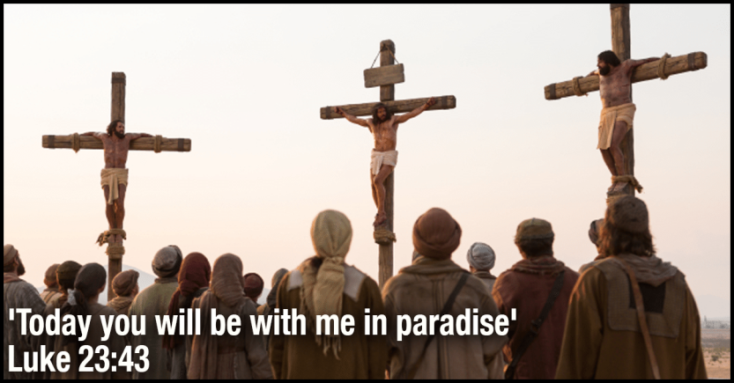
Arthur Simon Flegenheimer was born on August 6, 1902 in the Bronx. His parents were both German Jews. Later in life he became the notorious gangster known as Dutch Schultz On Wednesday evening, October 23, 1935, Dutch Schultz was sitting with three companions in the rear of a tavern, the Palace Chop House in Newark, New Jersey. Dutch was a power in the underworld. He was a criminal of criminals. His name was linked with every type of crime from robbery, bootlegging, extortion, to cold-blooded murder. As he sat there scheming with his gang, two men suddenly stood in the doorway with roaring guns. Critically wounded, Schultz staggered to the door. He was rushed to a hospital where he registered as a Jew; but next morning, feeling sure that he was face to face with death, he called for a Catholic priest. Father Cornelius McInerney was summoned. Schultz wanted to die a Catholic. Father McInerney gave him a few simple instructions, baptized him, and gave him the last rites of the Catholic Church. This arch criminal died Oct. 24, 1935. Dutch Schultz was buried from a Catholic church Oct. 28, 1935 and was buried in a Catholic cemetery the newspapers, on the subways, in the office buildings. People could not understand how the Church would accept such an evil man into her fold.
Though the infamous commandant of the Auschwitz concentration camp, Rudolf Höss, oversaw the murder of millions of innocent people during World War II, in the end, even his horrific sins weren’t bigger than the mercy of God. Despite overseeing the execution of millions, eyewitness accounts identified Höss as someone who always seemed calm and collected. He lived in a house with his family mere yards from the Auschwitz crematorium, kissing his wife each morning before work and tucking his five children into bed at night. Also under Höss’ watch, in the basement of block 11, prisoner number 16770 was committed to a starvation cell before dying by lethal injection. That prisoner was the priest and martyr St. Maximilian Kolbe.
After the war came to an end and Höss was captured, he was arraigned at the International Military Tribunal in Nuremberg and sentenced to death... Höss came to realize that everything he had lived, worked, and killed for was based on a flawed ideology, and he repented. He said: I have inflicted terrible wounds on humanity. I have caused unspeakable suffering for the Polish people in particular. I am to pay for this with my life. May the Lord God forgive one day what I have done? On Good Friday, April 4, 1947, awaiting execution, Höss asked to see a Catholic priest. Fr. Lohn heard Höss’ Confession. The next day, Friday, Höss received Holy Communion. Afterward, he knelt in his cell and wept. On April 16, Höss was hanged on a one-person gallows right outside of the gas chambers he had built in Auschwitz. The official report of his death said that Höss remained “completely calm right up to the end and expressed no final wishes. “It was a hard struggle,” Höss had written toward the end. “But I have again found my faith in my God.”
Did Dutch Shultz the murdered deserve mercy? Even more difficult to comprehend is that one of the key perpetrators of the Holocaust could go to confession and then receive Holy Communion. This is too much. How can the church do such things? It is too much. It makes no sense to us. Then we read in the second last word of Jesus from the cross:
From the Gospel of Luke: Now one of the criminals hanging there reviled Jesus, saying, “Are you not the Messiah? Save yourself and us.” The other, however, rebuking him, said in reply, “Have you no fear of God, for you are subject to the same condemnation?¹ And indeed, we have been condemned justly, for the sentence we received corresponds to our crimes, but this man has done nothing criminal.” Then he said, “Jesus, remember me when you come into your kingdom.”³ He replied to him, “Amen, I say to you, today you will be with me in Paradise.

