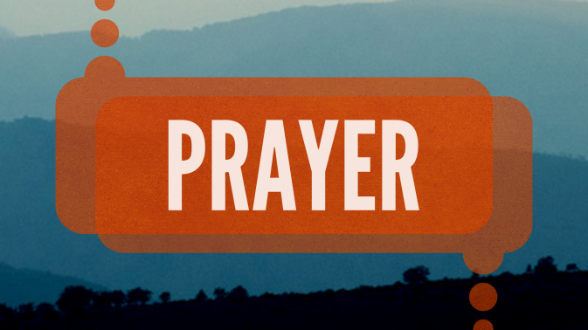
The captain of the large passenger airline came over the loudspeaker and informed the passengers that the three of the engines of the plane had stopped working and that the people needed to be prepared for a possible crash landing. Naturally, people started to scream and shout out their concerns. One passenger told the passengers to pray. So, they started to pray. One fellow sat quietly without seeming to pray. He was told by the other passengers to pray. He said he didn’t know any prayers. Someone said to do, at least do something religious. So, the fellow jumped and started taking a collection.
There are many jokes about prayer. In spite of how secular our society is becoming, here are some interesting statistics on prayer: For many Americans, every day is a day of prayer. More than half (55%) of Americans say they pray every day, according to a 2014 Pew Research Center survey while 21% say they pray weekly or monthly and 23% say they seldom or never pray. Even among those who are religiously unaffiliated, 20% say they pray daily. In the last few days, two of the most important political figures in America have spoken about prayer: Donald Trump Urges Prayers for 'Very Sad' Nancy Pelosi; and in turn, Nancy Pelosi is Praying for Trump After 'Serious Meltdown' I will let the Lord figure out whom best to listen to.
Those of us who remember our Baltimore Catechism will remember the classic definition of prayer: prayer is the lifting of the mind and heart to God. Another way to describe prayer is to call it a conversation with God. Prayer is about both talking to God and listening to God. The Lord has his own way of speaking to us in a variety of way, most often in the silence of our hearts and in gentle whispers but there are times when he speaks to us reveals his love for us, often through ordinary and extraordinary prayers.
I think many of us when we think about prayer are akin to hearing about the need to exercise or eat proper foods. We all shake our heads in agreement but it can hard and challenging to make the time and effort to enter into prayer. We know a relationship builds very much on communication. We speak to those we love about the thousands or ordinary moments of our days and also about the most dramatic and challenging. We love to share good news with one another and also speak of our burden and sorrows so they are lightened.
Even though we have more tools today than any time in history to communicate between the internet and our cell phones; I find that our age may communicate less well than previous generations. I sometimes have observed a family of four siting at a table in a restaurant and each is on their phone. Still, I only noticed it when I put my own phone down. The sign of a healthy relationship is good communication. I remember the lyrics of a John Denver song about a couple: I am lying here right beside you and I have never felt more alone.

In the Gospel today hear about a persistent widow who wears down a judge by her constant demand for justice. It is an image of Jesus speaking about prayer. The logical way to think about this parable is to see yourself as the widow trying to get the attention of God so that he will listen to you. An interpretation I like of these words of Jesus is that God is the widow and we are the judge. He is trying to get our attention. The great fourth century theologian, St. Augustine, captures this truth with these words: “You called and shouted and burst my deafness. You flashed, shone, and scattered my blindness. You breathed odors, and I drew in breath and panted for you. I tasted, and I hunger and thirst. You touched me, and I burned for your peace.”
There are many ways to pray: we have vocal prayers such as the Our Father, The Hail Mary, The Glory be. We can pray from a prayer book, say the divine mercy prayer or the rosary. Many of us like to simply sit and pray in our own words or follow the words of the Psalmist: be still and know that I am God. A wonderful way to pray is to read a few verses of the Bible and pause to hear what is God saying to me in these words.
I am so happy with being here at St. Mary’s. I love our beautiful property and churches, the great life and energy in our schools, the wonderful clergy and staff, the numerous ministries of the parish filled with parishioners, the generosity of our people to the parish and to those in need. What a joy to be part of this community of faith and prayer. I will tell you what has moved me most in an extraordinary way is the prayer chapel where Jesus is adored 24 hours a day, 365 days a year. That little chapel where so many pray so regularly is a great power source of parish. Whether you stop by for five minutes or make a holy hour, thank you for your prayerfulness and powerful witness.
I do not want to fail to mention our greatest prayer which is what we do here at this Mass and every Mass. The celebration of the Holy Mass is our greatest prayer since we pray to the Father in the name of the high priest Jesus through the power of the Holy Spirit. We had a wonderful talk a month or so ago by Matthew Kelly. He gave us listeners a very practical idea about our presence at Mass. He said: try to take one thought home with you from Mass. It might have been in a song, in the readings, the homily, a prayer, or a silence of our hearts as we received the Body of Christ. Lord, teach us to pray.

