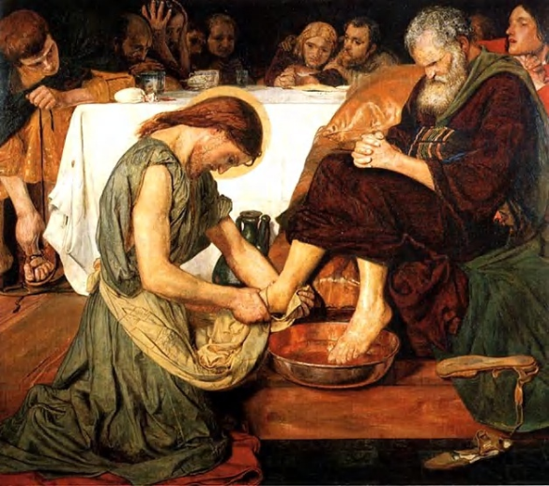
Last weekend, I had friends visiting from Long Island and we had a nice weekend sightseeing around Annapolis. We did a tour of the Naval Academy which was very inspiring. I had done it before, but I enjoyed learning about the life of midshipman and all they go through to serve our nation as officers. The other highlight for me was the visit to the State Capitol. As you know it is a beautiful building where some very significant historical events have occurred. Here is a quote about one of the events: On a cold day in Annapolis, Maryland on December 23, 1783, to the surprise of the world, General George Washington, the victor of the revolution, resigned his military commission to the leaders of the thirteen colonies that had just defeated the British I the American Revolutionary War. There are paintings and a statue in the Capitol that honor this moment. The revolutionary was truly ended in the moment-with yet another revolutionary act. Washington, who could have easily assumed a dictatorship, taken military control of the colonies, or declared himself king, removed himself from leadership. King George III, the King of English, upon hearing this news, supposedly remarked to an American painter, If Washington did that; he will be the greatest man in the world. We know that eventually and reluctantly, Washington accepted his unanimous election as our first President.
History is always surprised to see a leader give up his or her power. I once held a high leadership position in the Redemptorists for six years; I decided to withdraw my name from the election process when another terms was coming. I must confess it was not done less out of humility and more with the fear that I would not win the election; I would rather leave on my own then be defeated. Ah, Pride!
I have this dream, perhaps fantasy would be a would be a better term, of President Trump and House Speaker Nancy Pelosi holding a joint press conference in which they each admitted their faults, asked forgiveness of each other, and promised to work humbly together for the good of our country. That is almost as likely as the New York Jets winning the Super Bowl in the near future.
We celebrate this last Sunday of the Church year before Advent which begins next week, with the Feast of Christ the King. The Old Testament had its struggles with kings. The Jewish people longed for a King so they could be like other nations around them that had kings. Previously, the Jewish people were ruled by a council of judges, with the prophets and the priests being part of the governance structure. The prophets warned against Kings, arguing that there was only one King and that was God. They feared having a King since more the people from being concerned about the honoring the King than in obeying God. These prophecies often proved to be true.
Today, we proclaim Christ as King of the Heavens and the Earth. Our faith teaches us that God is the Creator of Heaven and Earth. God is all- knowing, all loving, all wise; a God who is eternal with no beginning and no end. He is who is. The Blessed Trinity has revealed so much through the incarnation of Jesus and through the power of the Holy Spirit. Our second reading from St. Paul, a text that Biblical scholars believe was a hymn sung by the early Christian community says, Jesus is the image of the invisible God, the firstborn of all creation. For in him were created all things in heaven and on earth, the visible and the invisible, whether thrones or dominions or principalities or powers; all things were created through him and for him. He is before all things, and in him all things hold together. We bend the knee and bow before Jesus the Lord of Heaven and Earth.
Where do we encounter this King? Do we go to Buckingham palace? Do we go to Wall Street, or the White House? Do seek in worshipped athletes, singers, actors and actresses our modern society or the Great scientists and medical wonders of today? We live in a world that was shocked to see a pope carry his own bags and wash the feet of prisoners.
Where is the throne of the Christ the King? It is a manger in a stable in Bethlehem, in man washing the dusty feet of his apostles, in an encounter with a foreign woman at well in Samaria. Where is this King exalted: with a crown of thorns pressed into his head and then mounted on a cross to die an agonizing death. The words Jesus of Nazareth King of the Jews are nailed to that cross. Behold your King. Our King comes to us hidden in the simplest form of bread and wine. Jesus at the Last Supper blesses the bread and says: This is my body, this is my blood. He remains in every tabernacle of the world. Paul’s letter to the Philippians speaks the eternal truth to us:
At the name of Jesus every knee should bow, of things in heaven, and things in earth, and things under the earth; and that every tongue should confess that Jesus Christ is Lord, to the glory of God the Father.

